|  |
| --- |
|  |
| Quick Start Guide for SR PadLock |
| Version 01.01.02 |



# Table of Contents

Table of Contents 2

1. Interface Schematics 3

1.1. Add or Replace Battery 3

2. Download and Install SR Smart App for iOS 4

2.1. Download the “SecuRemote® Smart” Application from Delphian server 4

2.2. Download the SR Smart App through App Store 5

3. Download and Install the SR Smart App for Android 8

3.1. Download the “SecuRemote® Smart” Application from Delphian server 8

3.2. Download the SR Smart App through Play Store 9

4. Operate SR Device 11

4.1. Register Device using Scan “QR Code” 11

4.2. Register Device manually 13

5. Operate SR PadLock 15

5.1. Unlock Operation 15

5.1.1. SR PadLock operate using SR Smart App 15

5.1.2. SR PadLock Unlock using Auto Unlock Enable 16

5.2. Lock Operation 17

5.2.1. LED is blinking after pull shackle 17

5.2.2. SR PadLock is in Unlock state and RED LED is off 17

6. Firmware Upgrade 18

7. FAQ 19

# Interface Schematics

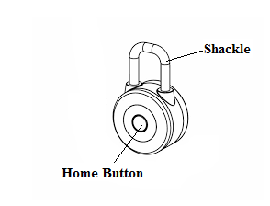

Figure 1

## Add or Replace Battery

* Use two CR2032 coin cell battery.
* See the Battery status in SR App Home Screen.
* If Battery percentage less than 10% then RED LED will blink 2times speedy on SR PadLock and user can’t performed any operation with SR PadLock.
* Please replace the Battery.
* Open the cap and add/replace the new Battery into SR PadLock.

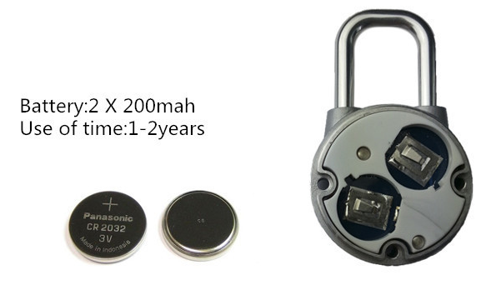

Figure 2

# Download and Install SR Smart App for iOS

Note:

1) If User already installed the SR Smart App then he/she should start with operate add device process.

2) To download latest app follow process of chapter #2.1, in future follow process of chapter #2.2.

## Download the “SecuRemote® Smart” Application from Delphian server

1. You can directly download app from below link: <https://www.delphiansystems.com/sr/apple/>
2. Tap on “Install SR Smart Application (Version 01.02.01)” link to download latest app V01.02.01 from above URL. Click on ‘Install’ option when it prompt.
3. By default, the “SR Smart™ App icon” will be placed in the first available spot on your home screen after installed successfully.

Note: Make sure smartphone have data connectivity to download app.

**Application icon or logo:**



Figure 3

## Download the SR Smart App through App Store

1. Click on “App Store Icon” to open app store. Refer Figure #4.
2. Search “SecuRemote Smart” keyword to find SR Smart™ application. Refer Figure #5.
3. Click on “GET” option. Refer Figure #6.

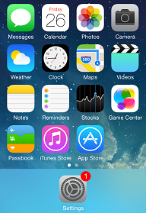 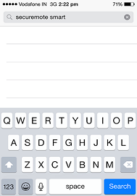 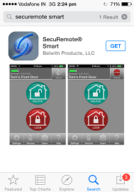

Figure 4 Figure 5 Figure 6

1. Click on “INSTALL” to start installation of SR Smart application. It will prompt for an apple ID and password to begin SR Smart application download. Refer Figure #7.
2. Click on “OPEN” to launch the SR Smart app. Refer Figure #8.
3. SR Smart app launching screen appear. Refer Figure #9.

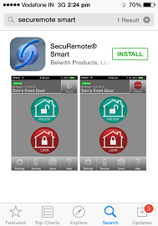 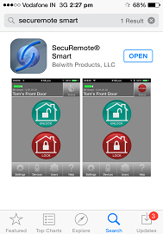 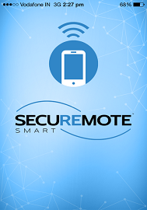

Figure 7 Figure 8 Figure 9

Note: By default, the “SR Smart™ App icon” will be placed in the first available spot on your home screen.

1. Click on “Allow” when it prompt for “Allow ‘SR Smart’ to access your location event when you are not using the app?” Refer Figure #10.
2. Add SR Device screen will open by default. Refer Figure #11.

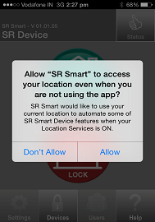 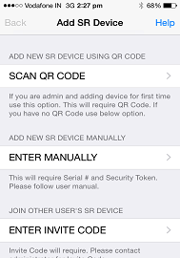

Figure 10 Figure 11

# Download and Install the SR Smart App for Android

Note:

1) If User have already installed the SR Smart App then he/she should start with add device process.

2) To download latest app follow process of chapter #3.1, in future follow process of chapter #3.2.

## Download the “SecuRemote® Smart” Application from Delphian server

1. You can directly download app from below link

<https://www.delphiansystems.com/sr/android/>

1. Tap on “Install SR Smart Application (Version 01.02.01)” link to download latest app V01.02.01 from above URL. It will start downloading automatic.
2. Now go in Download folder from mobile and click on “SecuRemoteSmart_01.02.01.apk” file.
3. Click on “Next” button from SR Smart App.
4. Again click on “Next” button from SR Smart App.
5. Now click on “Install” button to install application and it will start installing process.
6. Click on “Open” option to launch the SR Smart app and it will display “Add SR Device” screen by default.

Note for Android user only: Make sure “Unknown Sources” option is selected under “Setting🡪Security🡪Unknown Sources”)

Note***:*** Make sure smartphone have the data connectivity to download app.

**Application icon or logo:**



Figure 12

## Download the SR Smart App through Play Store

1. Click on “Play Store” icon to download SR App. Refer Figure #13.
2. Search “SecuRemote Smart” keyword to find SecuRemote® Smart application. Refer Figure #14.
3. Click on SecuRemote® Smart app to “INSTALLED” application. Refer Figure #15.

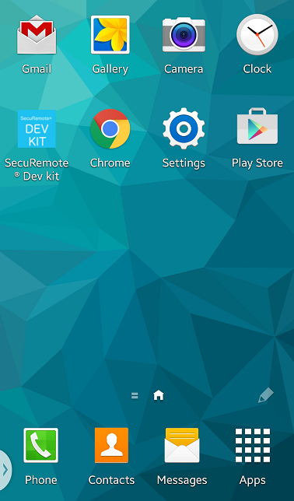 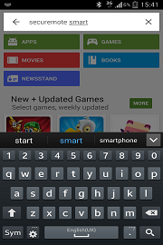 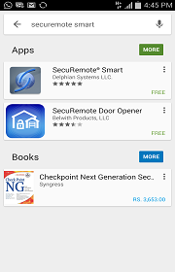

Figure 13 Figure 14 Figure 15

1. Click on “INSTALL”, to start installation of SR application. Refer Figure #16.
2. Click on “ACCEPT” option for Google play terms and condition. Refer Figure #17.
3. Click on “OPEN” option to launch SR Smart app and it will display “Add SR Device” screen by default. Refer Figure #18.

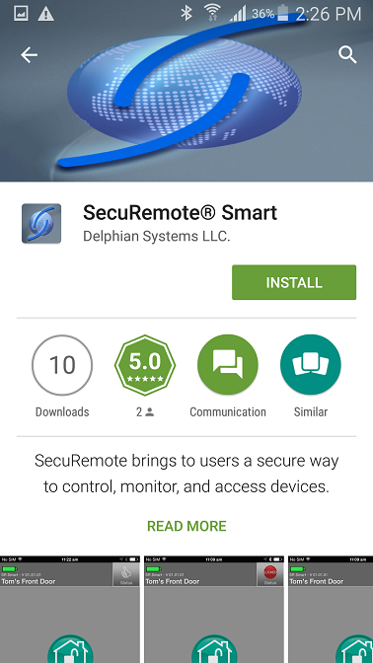 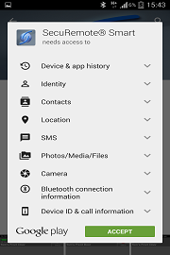 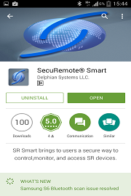

Figure 16 Figure 17 Figure 18

Note: By default, the “SR Smart™ App icon” will be placed in the first available spot on your home screen.

**Application icon or logo:**



Figure 19

# Operate SR Device

After successful installation of “SR Smart App”, SR Smart App icon will appear on smartphone home screen. User can register SR device using “Scan QR Code” or “Enter manually” options, after successful activation user can pair and operate SR PadLock.

Note: Make sure Data & Bluetooth connectivity is “ON”.

## Register Device using Scan “QR Code”

1. Open the SR Smart App, “ADD SR DEVICE” screen will open. Refer Figure #20.
2. Click on “Scan QR Code” option to add device, “Scan QR Code” will launch Camera to scan SERIAL # from user manual of SR PadLock. Refer Figure #21.
3. After QR Code is scanned successfully, SR Device information fill automatically in “ADD SR DEVICE” screen. Enter “SR Device Name” and click on “Create New Account” option. Refer Figure #22.

Note: If user have already created account on SR Portal then user can select “Choose Existing Account” option to ADD SR Device.

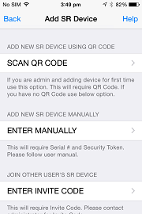 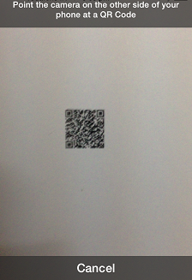 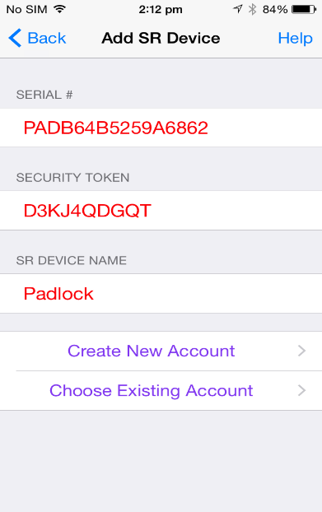

Figure 20 Figure 21 Figure 22

1. Enter all mandatory information in “Create SR Account” screen and click on “Register SR Device”. Refer Figure #23.
2. Enter all require SR Account details and click on “Registering SR Device” option, also click on “Home” button of PadLock then padlock is advertising for next 15 second and RED LED Blinks. Refer Figure #24.
3. After device is registered on SR Portal, it will redirect to app home screen and display “Padlock is paired successfully, you can start operate it now.” Toast message. Refer Figure 25.

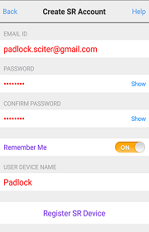 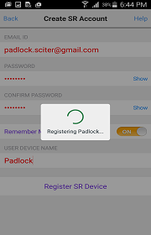 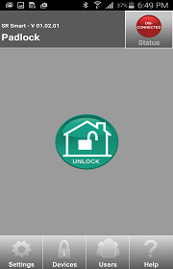

Figure 23 Figure 24 Figure 25

## Register Device manually

1. Open SR Smart App, “ADD SR DEVICE” screen will open, Click on “Enter manually” field to add device manually. Refer Figure #24.
2. It will display “ADD SR DEVICE” screen. Refer Figure #27.
3. Enter all require SR Device information and click on “Create New Account” or “Choose Existing Account” option to add SR Device information. Refer Figure #28.

Note: If user have already created account on SR Portal then user can select “Choose Existing Account” option to ADD SR Device.

 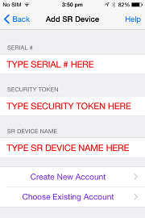 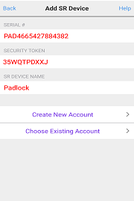

Figure 26 Figure 27 Figure 28

1. It will display “Create SR Account” screen. Refer Figure #29.
2. Enter all require SR Account details and click on “Registering SR Device” option, also click on “Home” button of PadLock then padlock is advertising for next 15 second and RED LED Blinks. Refer Figure #30.
3. After device is registered on server it will redirect to app home screen and display “Padlock is paired successfully, you can start operate it now.” Refer Figure #31.

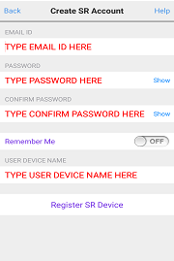 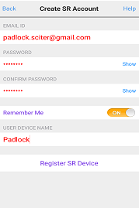 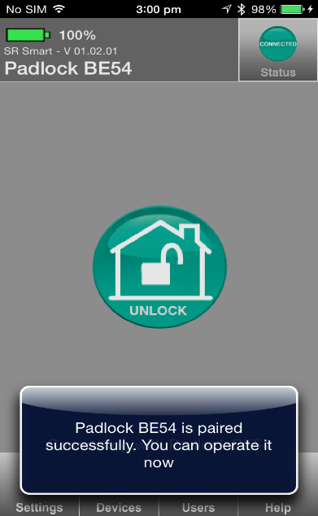

Figure 29 Figure 30 Figure 31

# Operate SR PadLock

There are two ways to operate the SR PadLock.

## Unlock Operation

Note: Default Auto unlock option is Enable

### SR PadLock operate using SR Smart App

* After add the SR PadLock into the SR Smart App, Make sure Bluetooth is Turn on.
* Press “Home” button of Padlock for getting the BLE connection and click on “Unlock” button of application, After Unlock operation performed successfully then it will display toast message “PadLock is Unlocked”.
* Pull the Shackle from the SR PadLock.

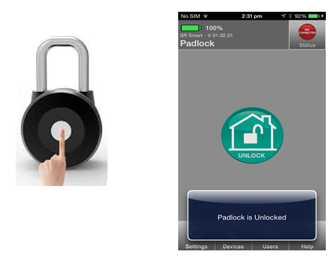

Figure 32

### SR PadLock Unlock using Auto Unlock Enable

* Make sure Bluetooth is ON.
* Go SR Smart App -> Settings->SR Smart APP Settings->Auto Unlock Enable. Keep SR Smart App running is in background mode.
* User don’t need to take phone out when Auto Unlock is Enable.
* When user will come within the SR PadLock range, just need to Press “Home” button from PadLock then pull shackle after BLUE LED converts into RED.
* Make sure pull shackle after finished BLUE LED blinking and RED LED is blinking.

Note: When no any LED blink at that time SR PadLock will remains on same state.

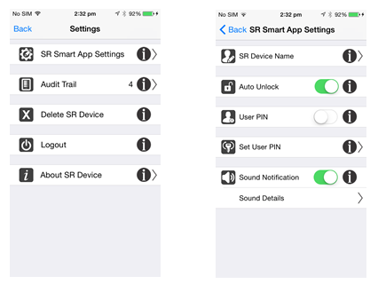

Figure 33

## Lock Operation

When SR PadLock is in unlock state then there are two possibility to lock the SR PadLock.

### LED is blinking after pull shackle

* After Padlock unlocked successfully, shackle can pull within 15 seconds.
* Once shackle pulled then again Red LED blink for 15 seconds for lock operation.
* User just need to push shackle for lock the padlock when RED LED is blinking.
* Once SR Padlock will locked successfully and LED will stop blinking.

### SR PadLock is in Unlock state and RED LED is off

* Make sure that SR PadLock is in Unlock state and shackle is pulled out from the latch.
* When no any LED blinking at that time user can Lock the SR PadLock by pressing “Home” button of SR PadLock and push the shackle within RED LED blinking for 15 seconds.
* SR PadLock doesn’t display any LED after Lock Operation performed successful.

# Firmware Upgrade

* When new firmware is uploaded on SR Portal then user go to SR Smart App-> Settings

->About SR Device->Firmware Upgrade and click on “Firmware Upgrade” option.

* Firmware is upgrade via Over The Air.
* After Firmware upgrade finished then it will display prompt message for “Firmware Upgrade is completed successfully”.
* During DFU Mode Red LED will remains on.

Note: Make sure while firmware upgrade, Auto unlock option is disable.

# FAQ

**Q1. How to download the mobile app?**

For iOS download latest app V01.02.01 from URL (<https://www.delphiansystems.com/sr/apple/>).

For Android download latest app V01.02.01 from URL (<https://www.delphiansystems.com/sr/android/>)

**Q2. How to enable or disable Auto Unlock setting?**

Go to SR Smart App🡪Settings 🡪 SR App Settings 🡪 Auto Unlock.

**Q3. How to do unlock padlock when Auto Unlock is enabled?**

Turn ON Bluetooth of smartphone, Keep app running in background and press Home button of Padlock if user is within the range of direct operation then unlock will done successfully without touch smartphone.

**Q4. How to do unlock padlock when Auto Unlock is disabled?**

Turn ON Bluetooth of smartphone, launch app and press Home button of Padlock and press Unlock button from app then unlock will done successfully.

**Q5. How to lock padlock when Red LED is blinking?**

When Red LED is blinking then just push the shackle and lock done successfully and LED stop blink.

**Q6. How to lock padlock when no LED is blinking?**

When no LED is blinking then press Home button of padlock and then just push the shackle and lock done successfully and LED stop blink.

**Q7. User need to take phone out to unlock Padlock when Auto Unlock is enabled?**

No, User don’t need to take phone out to unlock Padlock, user must be in range of direct operation and app is running in background and smartphone Bluetooth is ON.

**Q8. How to know app is running in background?**

**For iOS device**

Double tap on home button and mobile will display all the running app in background. If you find SR Smart app in list then it mean app is running in background.

**For Android device**

For Samsung S4 phone long press Home button from mobile and it will display all the running app in background. If you find SR Smart app in list then it mean app is running in background.

For Samsung S5 & S6 phone Tap on menu button from mobile and it will display all the running app in background. If you find SR Smart app in list then it mean app is running in background.